**Project Name:** Create Acronyms

**Github Link:** https://github.com/projectsforstudents2022/Create_Acronyms.git

**Why was this project created?**

When a phrase is used as a name, an acronym is a term created from the first letters of the words in the phrase. An acronym is a word that is created by combining the first letters, first syllables, or both the first letters and the first syllables of a set phrase. An acronym must typically only contain capital letters for each letter. An acronym, however, may become a regular term that is written in small characters if it has been in use for a while. Acronyms are used by writers to condense long, complex sentences into shorter ones while also saving space in their work.

**What problem is it solving?**

In other words, an acronym generator merely takes a string as input and outputs the initials of every word in the string. It is a shortened version of a word made up of several large words or phrases, like "natural language processing."

**Entire explanation of project**

* **PROPOSED APPROACH**

As defined by AcronymMaker, a token is a group of words from which one word must appear in the acronym. Or, to put it another way, a word from the collection and the created acronym must share a letter. Depending on the letter selection approach provided to AcronymMaker, this letter could either be the first letter of a word in the token or any other letter. Tokens might also be optional. When this occurs, AcronymMaker will attempt to match a letter from the words in the optional token to a letter in the acronym, but even if it is unsuccessful, the acronym will still be accepted. AcronymMaker searches a dictionary, or a collection of well-known words, for acronyms to fit a given string of tokens. If there is a letter from the word for each word in each (non-optional) token, the dictionary term is said to be described (as an acronym) by the sequence of tokens. In this instance, we say that the term that corresponds to the letter explains it. A word can be explained as an acronym in one of two ways: by adhering to the order of the tokens in the given sequence, or by doing so without doing so. Both are supported by AcronymMaker (independently).

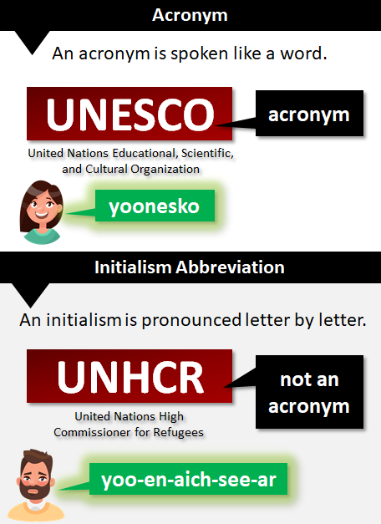

* **RESULT**

**CONCLUSION**

Time Complexity: O(n) -> looping once through an array of length n.

Space Complexity: O(n) -> as space is required for storing individual characters of a string and an array of length n.